

SPECTRUM ASTRO, INC.
high energy solar spectroscopic imager (hessi) program
attitude control subsystem
flight software specification
contract no. ppb005884

PREPARED BY:
SPECTRUM ASTRO, INC.
1440 N. Fiesta Boulevard
Gilbert, Arizona 85233
CAGE Code 0T9D1
INITIAL RELEASE DATE
2 SEPTEMBER 1999
1110-EW-S16620 | REV -
2 SEPTEMBER 1999
1110-EW-S16620

SPECTRUM ASTRO, INC.
high energy solar spectroscopic imager (hessi) program
attitude control subsystem
flight software specification)
contract no. ppb005884

REVIEWED BY:
 | CONFIGURATION/DATA CONTROL, DAVE MAIDEN | DATE
PREPARED BY:
 | ENGINEERING, GLENN CREAMER | DATE
APPROVED BY:
 | QUALITY ASSURANCE, JEFF SQUIRES | DATE
APPROVED BY:
 | SYSTEMS ENGINEERING, JOHN JORDAN | DATE
APPROVED BY:
 | PROGRAM MANAGER, JEFF PREBLE | DATE

REVISION SUMMARY

REV | RELEASE DATE | BRIEF DESCRIPTION/REASON FOR CHANGE | EFFECTIVE PAGES
- | 2 September 1999 | Initial release. | All
LIST OF ABBREVIATIONS AND ACRONYMS

ACS | Attitude Control Subsystem
ADP | Acceptance Data Package
CBE | Current Best Estimate
CDHS | Command and Data Handling Subsystem
CPU | Central Processing Unit
FOV | Field of View
HESSI | High Energy Solar Spectroscopic Imager
IAD | Inertia Adjustment Device
IDPU | Instrument Data Processing Unit
LV | Launch Vehicle
MAG | Three-Axis Magnetometer
PACI | Payload and Attitude Control Interface
PFS | Product Function Specification
RAS | Roll Angle Sensor
RPM | Revolutions Per Minute
S/C | Spacecraft
SAS | Solar Aspect System
SMS | Structures and Mechanisms Subsystem
SPI | Sun Presence Indicator
TQR | Torque Rod
TABLE OF CONTENTS
PAGE
1. INTRODUCTION 0
1.1 Scope 0
1.2 Classification 0
2. APPLICABLE DOCUMENTS 0
3. HESSI SPACECRAFT DEFINITION AND MISSION REQUIREMENTS 0
3.1 Spacecraft Description 0
3.2 ACS-Related Mission Requirements 0
3.3 ACS Sensor/Actuator Suite 0
4. SENSOR PROCESSING 0
4.1 Three-Axis Magnetometer 0
4.1.1 Magnetic Field Determination 0
4.1.2 Spin Rate Estimation 0
4.2 Coarse Sun Sensors 0
4.3 Fine Sun Sensor 0
4.4 Solar Aspect System 0
5. MODES OF OPERATION 0
5.1 Acquisition Mode 0
5.2 Precession Mode 0
5.3 Spin Mode 0
5.4 Normal Mode 0
5.5 Idle Mode 0
6. MODE CONTROL LOGIC 0
6.1 Acquisition Mode Control Logic 0
6.2 Precession Mode Control Logic 0
6.2.1 Coarse Precession Control 0
6.2.2 Fine Precession Control 0
TABLE OF CONTENTS (CONTINUED)
PAGE
6.3 Spin Mode Control Logic 0
6.4 Normal Mode Control Logic 0
6.4.1 Precession/Nutation Control 0
6.4.2 Spin Rate Control 0
6.5 Idle Mode Control Logic 0
6.6 Mode Transition Logic 0
6.7 On-Orbit Balance Operations 0
7. COMMAND, INTERFACE, AND TELEMETRY PARAMETERS 0
7.1 ACS Command Parameters 0
7.2 ACS Flight Software Interface Variables 0
7.3 ACS Telemetry Parameters 0

LIST OF FIGURES
Figure 3-1. HESSI Spacecraft With ACS Components 0
Figure 3-2. On-Orbit Configuration 0
Figure 4-1. CSS Coverage for a 70 Degree Cone Angle Threshold 0
Figure 4-2. FSS Coordinate System and Solar Aspect Angle Definitions 0
Figure 5-1. Mode Definitions and Transitions 0

LIST OF TABLES
Table 3-1. ACS-Related Mission Requirements 0
Table 3-2. ACS Equipment List 0
Table 5-1. ACS Hardware Utilization 0
Table 6-1. Mode Transition Logic 0
Table 7-1. ACS Command Parameters 0
Table 7-2. ACS Flight Software Input Variables 0
Table 7-3. ACS Flight Software Output Variables 0
Table 7-4. To_Idle_Flag Description 0

1. INTRODUCTION

1.1 Scope
This specification establishes the design and algorithm development of the Attitude Control Subsystem (ACS) as implemented on the High Energy Solar Spectroscopic Imager (HESSI) spacecraft. The specification encompasses all modes of operation for the spacecraft, transition logic between modes, sensor processing, on-orbit balancing, uplinkable command parameters, and hardware and software telemetry points. This specification is proprietary to Spectrum Astro, Inc.

1.2 Classification
This document is UNCLASSIFIED.

2. APPLICABLE DOCUMENTS
No additional documents are referenced in this specification.

3. HESSI SPACECRAFT DEFINITION AND MISSION REQUIREMENTS
The HESSI spacecraft and its mission are briefly described in this section, with emphasis on the ACS components and specifications. The description includes component identification and layout, coordinate frames, on-orbit configuration and parameters, and control objectives and requirements.

3.1 Spacecraft Description
The HESSI spacecraft, depicted in Figure 3-1, is composed of a primary truss structure housing a cylindrical scientific imager, four solar arrays extending from the structure, and a variety of subsystem components attached within the structure shell. The entire bus is spin-stabilized about the imager (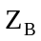) axis at 15 RPM to achieve dynamic stiffness. The solar arrays along the positive 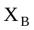 and 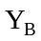 axes possess on-orbit angular adjustment capability using Inertia Adjustment Devices (IAD) at their root to minimize products of inertia. The ACS hardware suite consists of eight Coarse Sun Sensors (CSS) with two located at the ends of each array, one Fine Sun Sensor (FSS) located at the front of the Imager, one Three-Axis Magnetometer (MAG) located on the – face of the structure, and three Electromagnetic Torque Rods (TQR) located along the , , and directions. The scientific imager contains a Solar Aspect System (SAS) which provides Sun vector information and a Roll Angle Sensor (RAS) which provides phase angle information about the spin axis. The ACS utilizes the SAS output as a backup sensor in the event of FSS failure and as a primary sensor for balancing the spacecraft with the IADs. Each of these components is described in detail in Section 3.3 and in Section 4. Though not formally part of the ACS hardware suite or the flight software, a brief description of the IAD and the on-orbit balancing procedure is provided in Section 5.

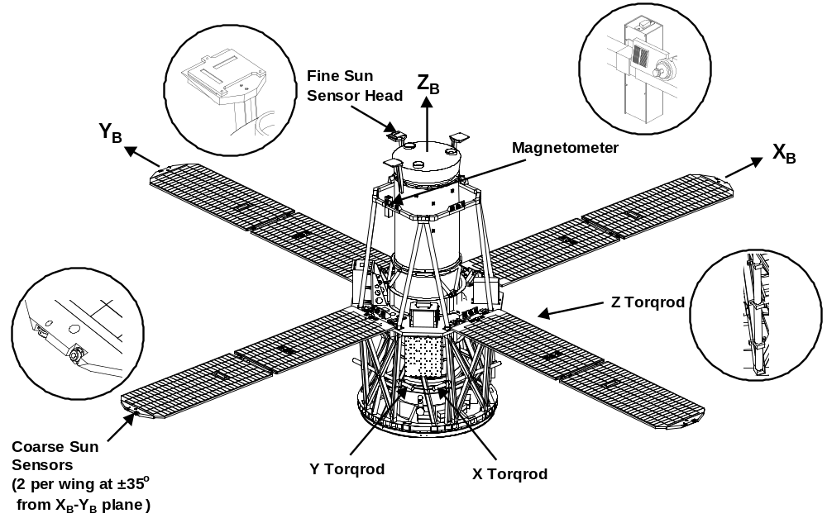
3-1. HESSI Spacecraft With ACS Components

3.2 ACS-Related Mission Requirements
The nominal HESSI scientific mission is to study the physics of solar flares over a two-year period. This will be achieved by pointing the Solar Spectroscopic Imager towards the Sun using the torqrods to reject both on-board and environmental disturbances as well as to track the 1 degree/day relative motion of the Sun line, as depicted by the on-orbit configuration in Figure 3-2. The primary ACS-related mission requirements, provided in Table 3-1, are to limit pointing errors to 0.2 degrees and maintain a spin rate of 13 to 17 RPM with a rate stability of less than 180 arcseconds in 10 revolutions. The ACS must also be capable of establishing Sun acquisition from any initial orientation upon launch vehicle separation.
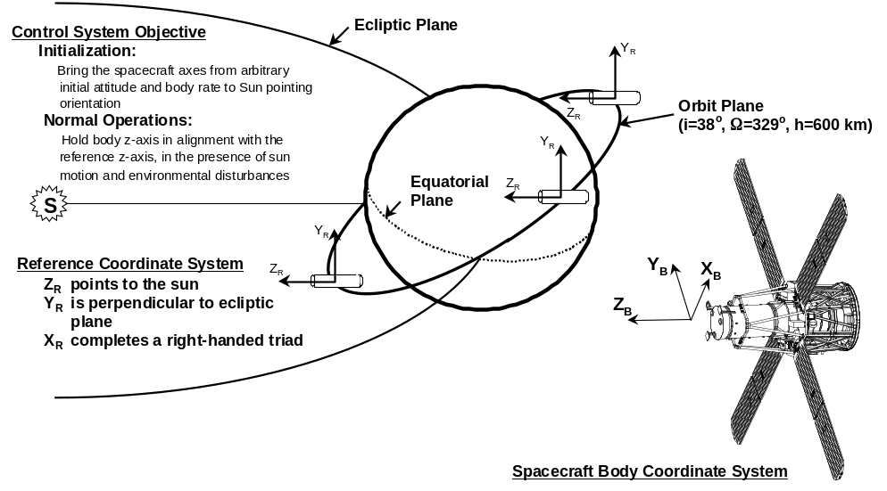
3-2. On-Orbit Configuration
3-1. ACS-Related Mission Requirements
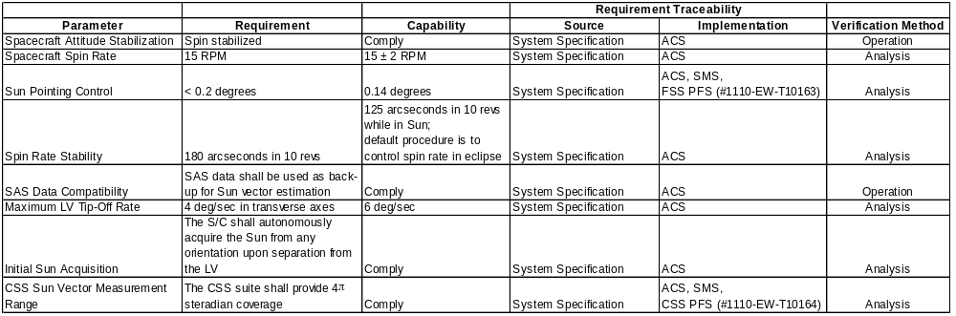

3.3 ACS Sensor/Actuator Suite
As described previously, the ACS hardware suite consists of eight Coarse Sun Sensors, one Fine Sun Sensor, one Three-Axis Magnetometer, three Electromagnetic Torque Rods, and one Solar Aspect System as a backup Sun sensor. The CSS complement provides full 4π steradian coverage of the celestial sphere with a Sun vector accuracy of a few degrees. These sensors are primarily utilized during initial acquisition but may also be used for troubleshooting purposes. The FSS is the primary Sun sensor and is used in normal science-collecting operations and in initial acquisition (once the Sun is within the sensor’s 32 degree FOV). The FSS has a 3σ accuracy of 0.05 degrees within a 10 degree cone and 0.1 degrees outside the 10 degree cone. The MAG provides a measure of the local magnetic field in the S/C frame and is used to determine spin rate (from zero crossings of the X or Y components) and to calculate the appropriate dipole moments applied to the torque rods. Its 3σ accuracy is 4 milliGauss with a range of ±600 milliGauss. The three TQRs provide dipole moments on the S/C and, in combination with the Earth’s magnetic field, generate desired torque’s along each S/C axis. These actuators are used for precession control, nutation control, and spin rate control, and possess a linear dipole capability of 60 Amp-meters². The SAS is utilized as a backup Sun sensor in the ACS control loops and provides a 3σ accuracy of about 28 arcseconds within its 1 degree FOV.

The processing algorithms for each of the sensors are described in detail in Section 4. The components, except the SAS, are provided in Table 3-2.

3-2. ACS Equipment List
Subsystem | Component | Supplier | # Per Flight Shipset
ACS | Fine Sun Sensor Head | Adcole | 1
 | Fine Sun Sensor Electronics | Adcole | 1
 | Coarse Sun Sensor | Adcole | 8
 | Magnetometer | Ithaco | 1
 | Electromagnetic Torque Rod | Ithaco | 3

4. SENSOR PROCESSING
The processing algorithms for each ACS sensor are provided in this section. The outputs of these algorithms provide the necessary information which is utilized in the control laws of Section 6 to drive the torque rods and meet the ACS-related mission requirements.

4.1 Three-Axis Magnetometer
The Three-Axis Magnetometer provides a measure of the magnetic field vector in the S/C frame. The magnetometer processing algorithm consists of two components: calculation of the magnetic field and estimation of the S/C spin rate about the axis.

4.1.1 Magnetic Field Determination
The primary outputs of the MAG are three voltages proportional to the local magnetic field and one voltage proportional to the temperature. The field strength B in Teslas is given by

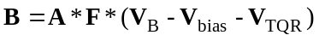;

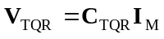;

where 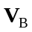 is the 31 vector of field voltages output from the MAG, 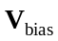 is the 31 vector of bias voltages, 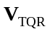 is the 31 vector of TQR-compensated voltages, A is a 33 alignment matrix, F is a 33 diagonal scale factor matrix in Tesla/volts, 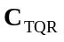 is the 33 TQR compensation matrix, and 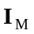 is the 31 vector of commanded TQR currents in amps. The TQR compensation matrix will be calibrated on the ground prior to launch and on-orbit prior to normal operations. The alignment and scale factor matrices will be calibrated by Ithaco and provided in their ADP. The calculated magnetic field B is filtered using a digital single-pole low-pass filter, as depicted by the z-domain transform

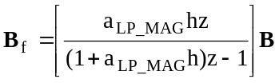;

where 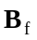 is the 31 vector of filtered MAG outputs in Teslas, 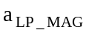 is the low-pass roll-off frequency in rad/sec, and h is the ACS sample period corresponding to the 8 Hz PACI sampling rate. The value for the roll-off frequency is chosen to be ten times higher than the spin rate of the spacecraft.

4.1.2 Spin Rate Estimation
Estimation of the spin rate about the axis is achieved by evaluating the zero crossing times of the X and Y components of the MAG output, as follows

If 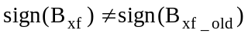
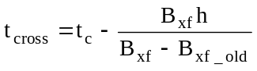;
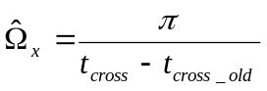;
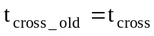;
End

where 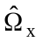 is the estimated spin rate from 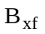in rad/sec, 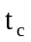 is the current time, 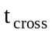 is the interpolated zero cross-over time, and 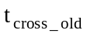 is the previous zero cross-over time (one period earlier) The value of – old is set to the most recent value of at the end of each sampling cycle.. The final spin rate estimate 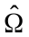 is determined from an average of the x and y estimates.

4.2 Coarse Sun Sensors
The Coarse Sun Sensors provide an estimate of the Sun vector in the S/C frame. Each sensor is simply a passive detector which outputs a current proportional to the cosine of the angle between the Sun and the sensor boresight. Therefore, each illuminated sensor gives the location of the Sun on a cone and at least three sensors need to be illuminated to uniquely determine the Sun vector. Since Earth albedo can be as high as 37% of full Sun at the 38 degree orbit plane inclination, its effect needs to be minimized by thresholding the current output of the sensors. The maximum output of each sensor is about 1.3 milli-amps when pointed directly at the Sun; hence, a threshold of 0.45 milli-amps limits the output to 34% of full Sun (corresponding to a FOV threshold of about 70 degrees). The sensor coverage for a 70 degree threshold is shown in Figure 4-1, where it is observed that full 4π steradian coverage is achieved. Although some regions provide only two-sensor coverage (and therefore no unique solution) the calculated Sun vector will still be approximately correct and will direct the S/C in the proper direction until three- or four-sensor coverage is obtained. If the 70 degree cone limit is reduced to 67 degrees (0.5 milli-amps or 39% of full Sun) small regions of one-sensor coverage appear. Again, these regions are not detrimental to the control performance.

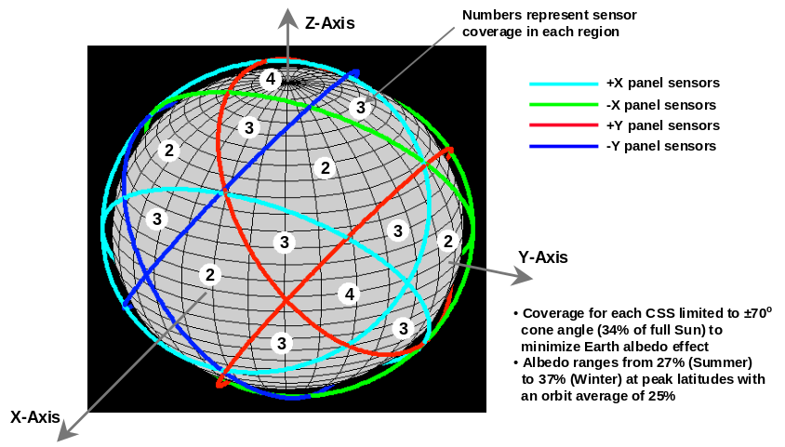
4-1. CSS Coverage for a 70 Degree Cone Angle Threshold
The CSS processing logic implements the following algorithm

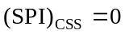;
k = 0;
For i = 1:8
If 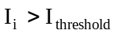
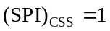;
k = k+1;
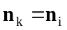;
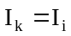;
End
End
If k == 1
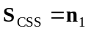;
Elseif k == 2
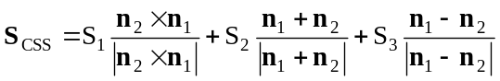;

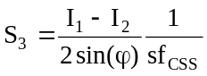;

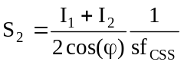;

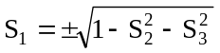;

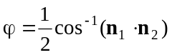;

Elseif k == 3
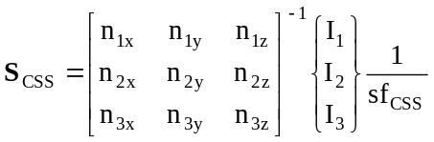;
Else
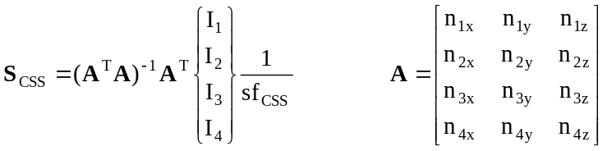;
End

where 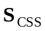 is the unit Sun vector, 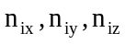 are the components of the unit boresight vector of the (i)th CSS, is the current output of the (i)th CSS in amps, 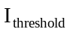 is the threshold value of current in amps, 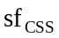 is the CSS scale factor in amps, and 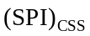 is a bi-level CSS-based Sun Presence Indicator which is equal to 1 when the Sun is in view and 0 otherwise. For the case in which only 2 sensors are illuminated (k == 2), the two solutions given above are compared to the previous Sun vector and the one closest to the previous solution is chosen.

4.3 Fine Sun Sensor
The Fine Sun Sensor is the primary ACS pointing sensor which provides a measure of the Sun vector in the S/C frame to a 3σ accuracy of 0.05 degrees. The FSS outputs both a coarse 6-bit gray code digital signal and two fine analog sine and cosine signals for each of two solar aspect angles α and β, as defined in Figure 4-2. The coarse digital signal provides the integer value for each aspect angle in 1 degree increments with a range of ±32 degrees. The fine analog signals provide the fractional components of the two angles. The procedure to obtain the two aspect angles and, hence, the unit Sun vector is as follows:

- Determine the fractional component 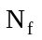 for each angle from the analog outputs using
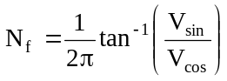

where 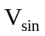 and 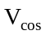 are the sine and cosine analog voltage outputs.

- Determine the integer component 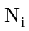 for each angle from the coarse digital outputs using
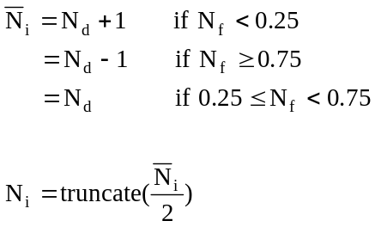
where 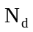 is the decimal equivalent of the 6-bit gray code.

- Determine the total error for each angle using
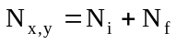
- Determine the projections of the Sun vector onto the X and Y axes using
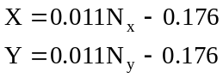
- Determine the two aspect angles using
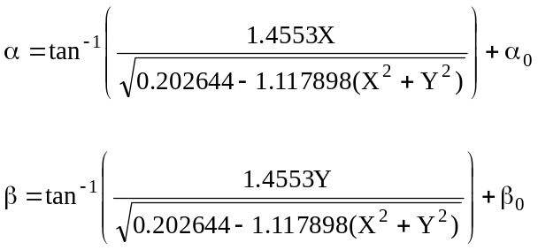

where 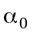 and 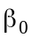 are fixed offset angles provided by Adcole.
- Determine the unit Sun vector using
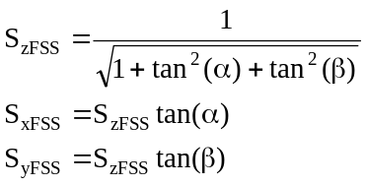
In addition to the Sun vector outputs, the FSS provides a bi-level Sun Presence Indicator, 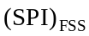, which is equal to 1 when the Sun is in view and 0 otherwise.

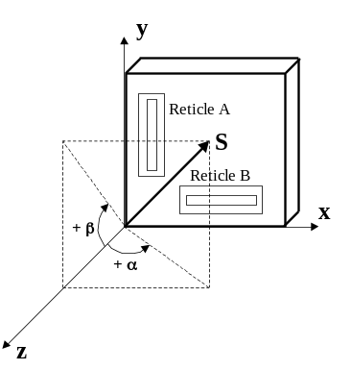
4-2. FSS Coordinate System and Solar Aspect Angle Definitions

4.4 Solar Aspect System
The Solar Aspect System is the primary sensor utilized during on-orbit balancing operations and the back-up sensor utilized in the event of FSS failure. The SAS output consists of packets of 8 X,Y pairs corresponding to 1 second of Sun vector information sampled at the IDPU rate of 8 Hz. The 1-second intervals are synchronized to the PACI 1 Hz clock. The packets are sent through a serial interface to the PACI with a 1-second delay and are read by the PACI in 0.5 seconds. Therefore, the total delay from the first X,Y pair to the current S/C time is 2.5 seconds.

The propagation logic transfers the 8 pairs of x,y counts to current S/C time and converts the counts to an equivalent Sun unit vector. The counts range from –128 to +127 with a conversion from counts to degrees of 1/128 degrees per count (±1 degree FOV). An output of X=-128 or Y=-128 indicates no solution. The propagation logic is as follows

For i=1:8
If 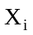==-128 OR 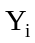==-128
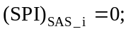
Else
;
;
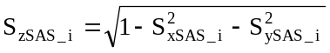
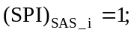
End
End

where and are the (i)th pair of outputs from the SAS in counts, 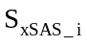, 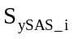, and 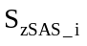 are the (i)th propagated components of the unit Sun vector in radians, 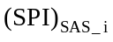 is the (i)th bi-level SAS-based Sun Presence Indicator, and 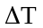 is the SAS processing delay in seconds.

5. MODES OF OPERATION
The five modes of operation for the HESSI spacecraft are briefly described in this Section. The modes and their transition paths are depicted in Figure 5-1 and the hardware utilization for each mode is provided in Table 5-1. The specific algorithms associated with each mode are described in detail in Section 6, as well as the transition logic between modes.

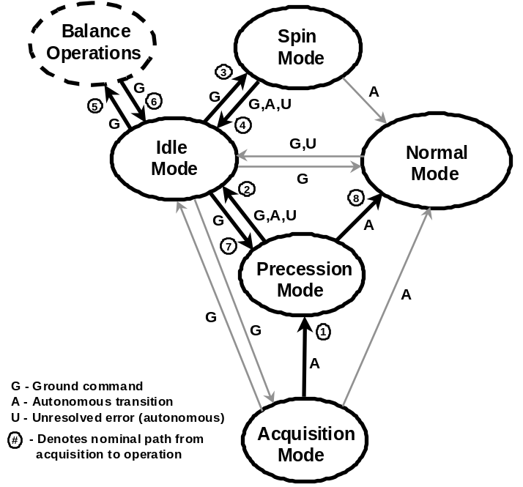
5-1. Mode Definitions and Transitions
5-1. ACS Hardware Utilization
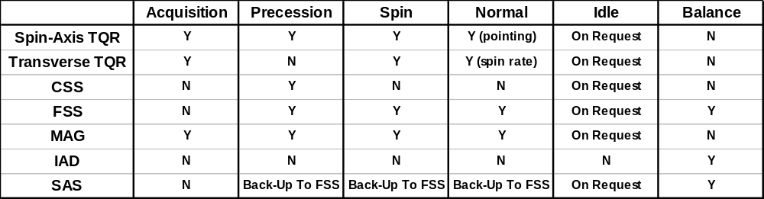

5.1 Acquisition Mode
The Acquisition Mode is the initial wake-up mode entered after release from the launch vehicle and upon any CPU reboots during the mission life. After release from the launch vehicle this mode establishes a prescribed slow spin rate about the spacecraft axis and damps the transverse rates about the other axes utilizing the MAG and TQR. The MAG output is also used to estimate the spin rate upon entering this mode and determine if the mode was entered from launch vehicle release or from a CPU reboot. If a reboot has occurred then the spin rate will be much higher than the initial 3 deg/sec release rate and will result in a transition to Normal Mode.

5.2 Precession Mode
The Precession Mode can be entered autonomously from Acquisition Mode and by ground command from Idle Mode. This mode establishes a Sun-pointing orientation from any initial attitude to within a fraction of a degree utilizing the CSS, FSS, MAG, and TQR.

5.3 Spin Mode
The Spin Mode is entered only by ground command from Idle Mode. This mode establishes the desired spin rate of 15 RPM while maintaining Sun-pointing orientation utilizing the FSS, MAG, and TQR.

5.4 Normal Mode
The Normal Mode is the primary science-collecting mode of operation and can be entered autonomously from Acquisition Mode, Precession Mode, or Spin Mode and by ground command from Idle Mode. This mode maintains a Sun-pointing accuracy of 0.2 degrees and a spin rate of 13 to 17 RPM utilizing the FSS, MAG, and TQR. Any unresolved pointing or spin rate errors within this mode result in a transition to Idle Mode.

5.5 Idle Mode
The Idle Mode is the safe-hold mode for the spacecraft and is reachable by ground command from any other mode. There are also autonomous transitions to this mode from the other modes based on nominal procedures or unresolved errors. Within this mode the torque rods are disabled and the spacecraft attitude/rate state remains approximately inertially-fixed with minor perturbations due to environmental and on-board disturbances. Exit from this mode to any others is by ground command only. Additionally, on-orbit balance operations are performed within this mode.

6. MODE CONTROL LOGIC
The control logic and algorithms for each of the five modes of operation, as well as the transition logic between each mode, are described in detail in this Section. Additionally, a description of the on-orbit balance procedure is provided at the end of the Section.

6.1 Acquisition Mode Control Logic
The Acquisition Mode is utilized to reduce transverse rates and establish a desired spin rate. A modified “B-Dot” control law is implemented wherein 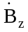 is driven to zero while 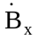 and 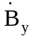 are driven to appropriate levels corresponding to a desired spin rate about the axis. The filtered MAG output is further filtered and differentiated using a second-order finite-difference estimator, resulting in a rate-of-change of the magnetic field in the transfer form

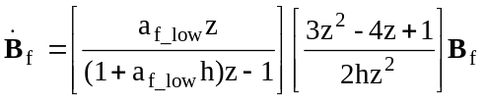;

where 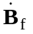 is the 31 vector of filtered field rates in Tesla/sec and 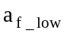 is the low-frequency filter roll-off rate in rad/sec. The commanded TQR dipole moments and currents then become

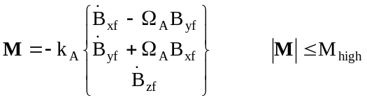;

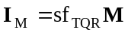;

where M is the 31 vector of commanded dipole moments in amp-m² (restricted to 60 amp-m²), 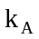 is the acquisition control gain in amp-m²-sec/Tesla, 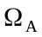 is the desired acquisition spin rate in rad/sec, 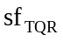 is the TQR scale factor in amps/amp-m², and 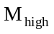 is the high setting for TQR saturation in amp-m².

6.2 Precession Mode Control Logic
The Precession Mode is utilized to establish precise Sun pointing from any arbitrary orientation prior to entering Normal Mode or Idle Mode. The control logic is dependent upon the combination of the Sun Presence Indicators from the CSS and the FSS. If is 1 and is 0 then a coarse CSS-based logic is executed, if is 1 then a fine FSS-based logic is executed, and if and are both 0 then no current is applied to the TQR (S/C is in eclipse).

6.2.1 Coarse Precession Control
The coarse precession control logic utilizes the CSS-measured Sun vector in combination with the rate-damping acquisition logic to precess the spacecraft. The control logic is as follows

If 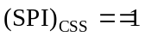 AND 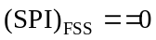
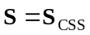;
;
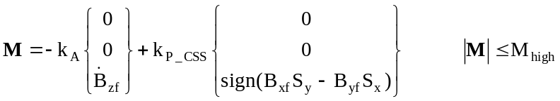;
;
End

where S is the measured Sun vector, and 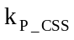 is the CSS precession control gain in amp-m².

6.2.2 Fine Precession Control
The fine precession control logic utilizes the FSS-measured Sun vector and the torque rod to precess the spacecraft. The logic combines both precession control and active nutation control to drive the transverse components of the Sun vector towards zero until the pointing error reaches a small value (i.e. 0.2 degrees). The active nutation control logic requires an estimate of the transverse S/C rates, which are determined from the filtered and differentiated FSS outputs. The precession/nutation logic is as follows

If 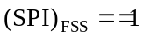
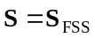;
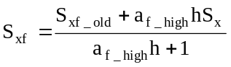; 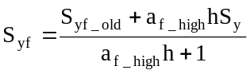;
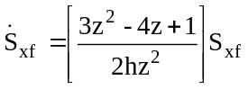; 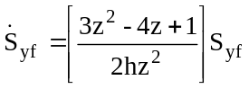;
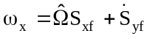; 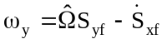;
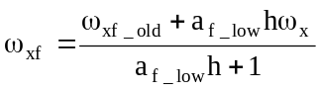; 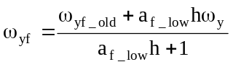;
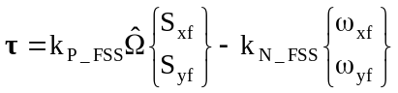;
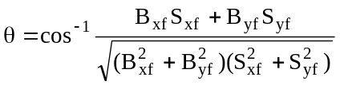;
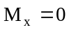;
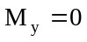;
If 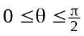
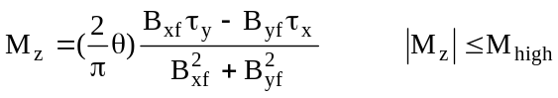;
Else
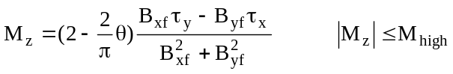;
End
;
End

where 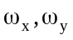 are the transverse rates in rad/sec, 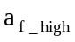 is the high-frequency filter roll-off rate in rad/sec, τ is the 21 torque vector in N-m, 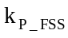 is the FSS precession control gain in N-m-sec, 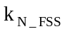 is the FSS nutation control gain in N-m-sec, θ is the angle in the 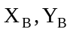 plane between the Sun vector and the magnetic field, and is the high setting for TQR saturation. The “dipole de-weighting” parameter 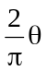 scales the control effort depending upon the angle in the x-y plane formed by the B-field vector and the Sun vector.

6.3 Spin Mode Control Logic
The Spin Mode is utilized to establish a desired spin rate about the axis using the estimated spin rate from the MAG processing output. Simultaneously, the identical fine precession control logic for the torque rod implemented in the Precession Mode is used to maintain Sun pointing during spin rate correction. The and torque rod dipole moments and currents are determined using a simple proportional control law with a minimum-norm solution of the form

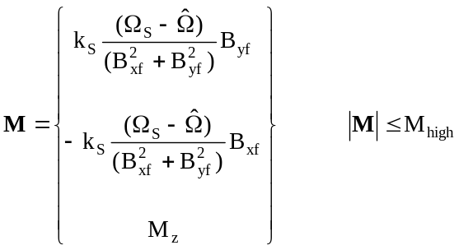;

;

where 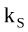 is the spin control gain in amp-m²-Tesla-sec, 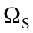 is the desired spin rate in rad/sec, and 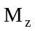 is the fine precession control dipole given in Section 6.2.2.

6.4 Normal Mode Control Logic
The Normal Mode represents the primary science-collecting mode and requires the tightest pointing accuracy and spin rate stability. Two control functions are performed within this mode: precession/nutation control to maintain the axis within a deadzone of the Sun line using the torque rod, and spin rate control to maintain the spin rate within a small deadzone about 15 RPM using the and torque rods.

6.4.1 Precession/Nutation Control
The precession/nutation control logic is very similar to that described under the Precession Mode logic, with the addition of a pointing hysteresis deadzone. The precession/nutation logic is as follows

If
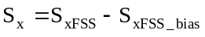;
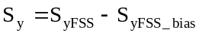;
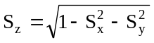;
;
; ;
;
;
;
;
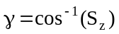;
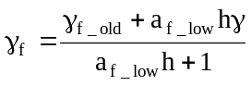;
If 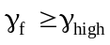 OR [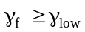 AND 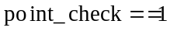]
point_check=1;
If
;
Else
;
End

Else
point_check=0;
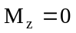;
End
Else
;
End
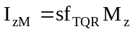;

where 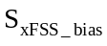, are the bias settings for the FSS, γ is the angle between the axis and the Sun line, 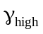 and 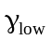 are the high and low hysteresis bounds on γ, point_check is a bi-level parameter indicating the previous state of the hysteresis loop, and 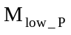 is the low setting for TQR saturation in precession control in amp-m². In the event of FSS failure, the Sun vector and SPI from the SAS will be utilized in place of the corresponding FSS signals.

6.4.2 Spin Rate Control
The spin rate control logic is very similar to that described under the Spin Mode logic, with the addition of a rate hysteresis deadzone. The spin rate logic is as follows

If 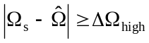 OR [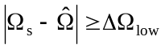 AND 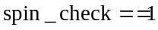]
spin_check=1;
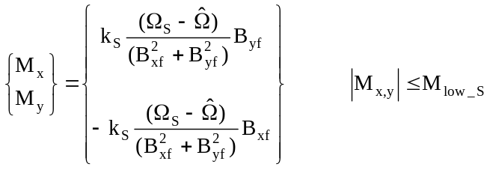;
Else
spin_check=0;
;
;
End
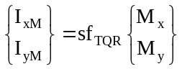;

where 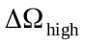 and 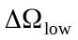 are the high and low hysteresis bounds on 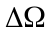 in rad/sec, spin_check is a bi-level parameter indicating the previous state of the hysteresis loop, and 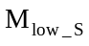 is the low setting for TQR saturation in spin control in amp-m².

6.5 Idle Mode Control Logic
The Idle Mode represents a safe-hold or wait mode with all three torque rods disabled. The commanded TQR dipoles and currents therefore become

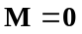;
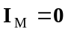;
until ground-command intervention.

6.6 Mode Transition Logic
The transition logic between each mode of operation is outlined in Table 6-1. The left-most column of the table represents the Mode the spacecraft is currently operating within and the upper-most row represents the Mode the spacecraft will transition to if the appropriate block logic is satisfied. For example, if the spacecraft is in Normal Mode, the only possible transition is to Idle Mode if the pointing error between the measured Sun vector and the spacecraft axis, β, exceeds its allowable bound or if the estimated spin rate, Ω, exceeds its allowable bound. The logic for transition from Acquistion Mode to Precession Mode is based on time from LV release and estimated spin rate. It is also observed that the bounds for transition to Normal Mode from either Precession Mode or Spin Mode must be tighter than the corresponding bounds within Normal Mode or a transition to Idle Mode will immediately occur. If the spacecraft is in Idle Mode, the only transition to any other Mode is through ground command. It should be stated that although the parameters are numerical in Table 6-1, they will actually be variables which can be modified and uploaded at any time during the mission life (see Section 7.1).

6-1. Mode Transition Logic
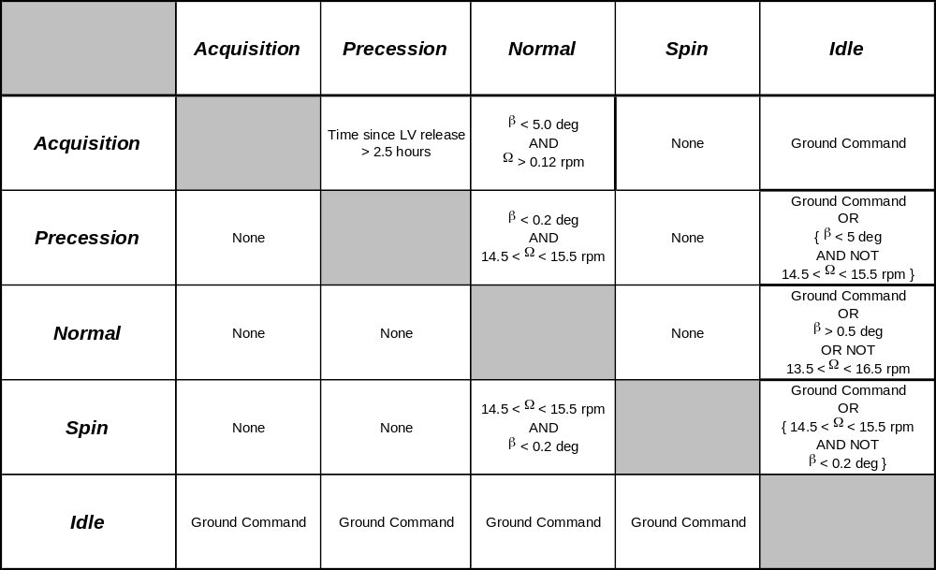
Note: Transition from Acquisition to Normal occurs only if β check is valid continuously for 10 minutes.

6.7 On-Orbit Balance Operations
On-orbit balance operations are performed within Idle Mode after initial Sun acquisition and, if required, periodically during the mission life. The balance procedure is performed entirely by ground command and monitoring and, hence, adds no flight software code to the processor. The procedure utilizes the IAD on each of the two positive-facing X and Y arrays to adjust the angle of the arrays such that the spin axis aligns itself with the HESSI Imager boresight axis. The IAD is a micrometer displacement device with a resolution of 0.00043 cm resulting in a spin axis angle resolution of 0.0022 degrees. Balancing is accomplished by monitoring the SAS Sun vector output on the ground and removing any biases associated with the X and Y components of that vector. The steps associated with this procedure are as follows
- Calculate the Imager unit Sun vector, 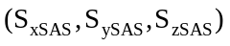, from the SAS output
- Average 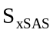 and 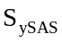 over a short time period to obtain the X,Y biases 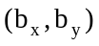
- Calculate the required X,Y array angles, 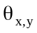, to remove these biases using
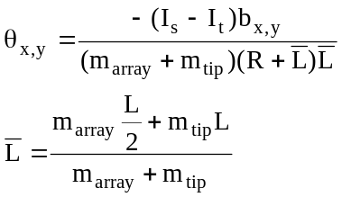
where is the spin inertia, is the transverse inertia, L is the length of the array, R is the radius of the cylindrical S/C bus, 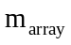 is the mass of the array (minus the tip mass), and 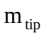 is the array tip mass.
- Determine commanded IAD displacements, 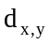, using
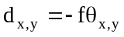
where f is the fulcrum arm length of 20.4 cm.

The above steps can be iterated if necessary until the desired balance accuracy is achieved.

7. COMMAND, INTERFACE, AND TELEMETRY PARAMETERS
Provided in this section are the wide range of uplinkable ACS command parameters, ACS flight software interface variables, and ACS downlinkable telemetry parameters. The command parameters can be uplinked as an entire table or, if desired, as a single parameter at a time. The telemetry parameters will be monitored on the ground to assess the on-orbit status and performance of the ACS and to assist in on-orbit troubleshooting.

7.1 ACS Command Parameters
The ACS command parameters are provided in Table 7-1. The table includes launch default values for each parameter. These parameters will be adjustable by ground command throughout the mission. The parameters with an asterisk vary autonomously during mission operation.

7-1. ACS Command Parameters
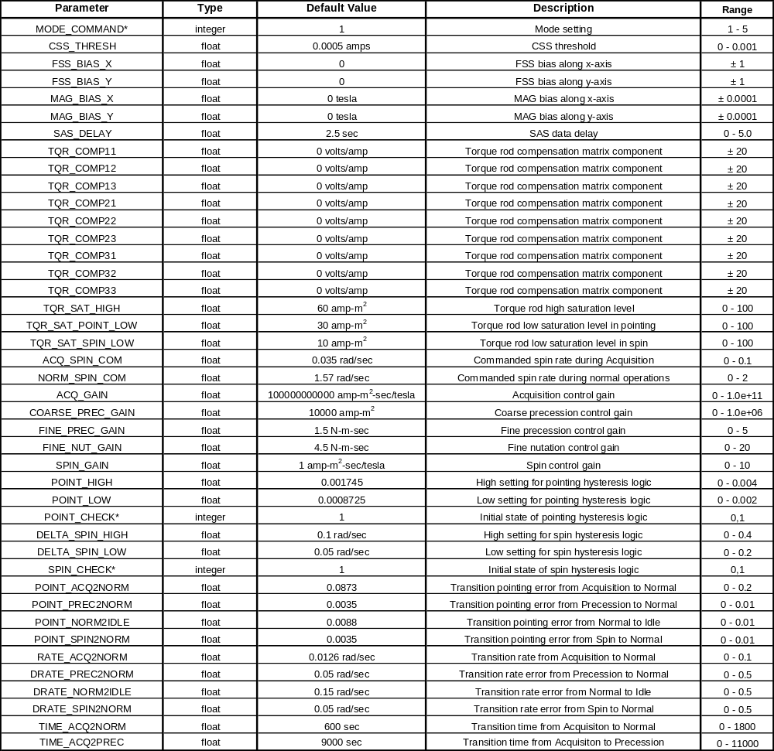

7.2 ACS Flight Software Interface Variables
The ACS flight software algorithms described in the previous sections will be converted into flight software C code using the Autocode utility provided with the AC1000 realtime development system (see Section 8). This C code will then be integrated with the remaining CDHS code to generate the complete flight software. Provided in Tables 7-2 and 7-3 are the input/output variables which interface to the CDHS code. Each input and output variable name, type, description, and range are given. The difference between mode_command of Table 7-1 and ground_mode of Table 7-2 is that mode_command simply initializes the mode, whereas ground_mode holds the mode until it is reset to zero (its default).

7-2. ACS Flight Software Input Variables
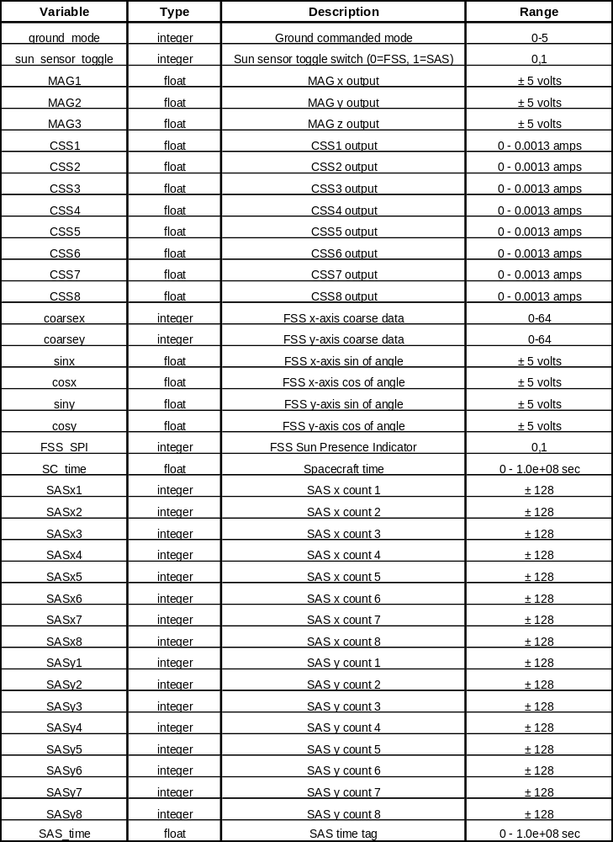

7-3. ACS Flight Software Output Variables
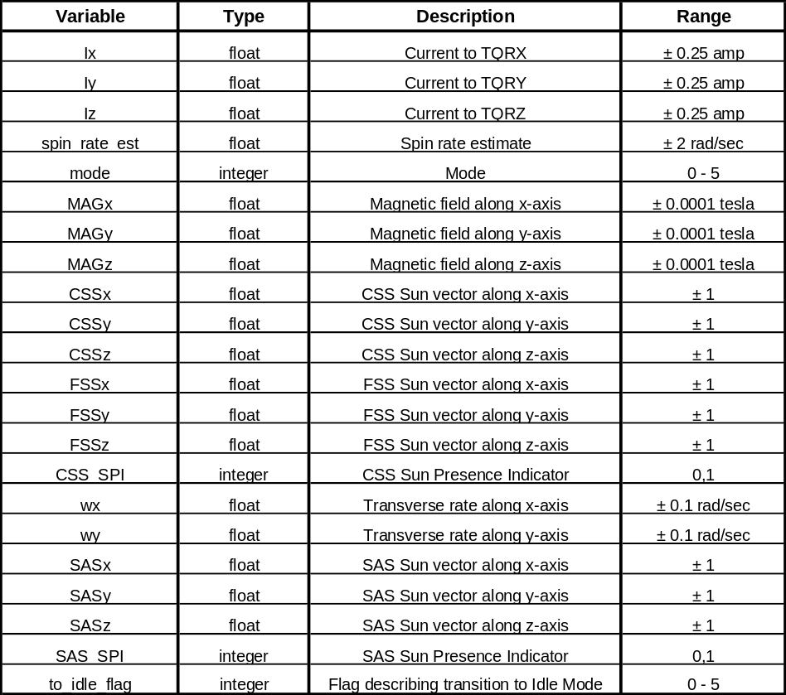

The to_idle_flag variable in Table 7-3 describes why a transition to Idle Mode has occurred. The definitions for this flag are provided in Table 7-4.

7-4. To_Idle_Flag Description
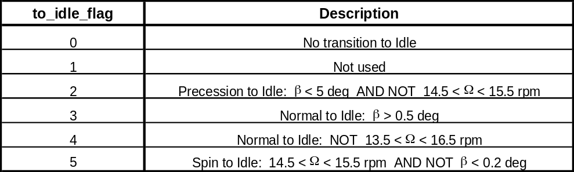

7.3 ACS Telemetry Parameters
The list of ACS telemetry parameters is identical to those 60 variables given in Tables 7-2 and 7-3, with the addition of the FSS state-of-health (FSS_SOH) parameter which is a float value ranging between 0 and 5 volts (with a nominal value of 3.5 volts), and the MAG temperature parameter which is a float value ranging between 0 and 5 volts (with a nominal value of 2.5 volts).

